1. Created a spark cluster using the azure HDInsight.

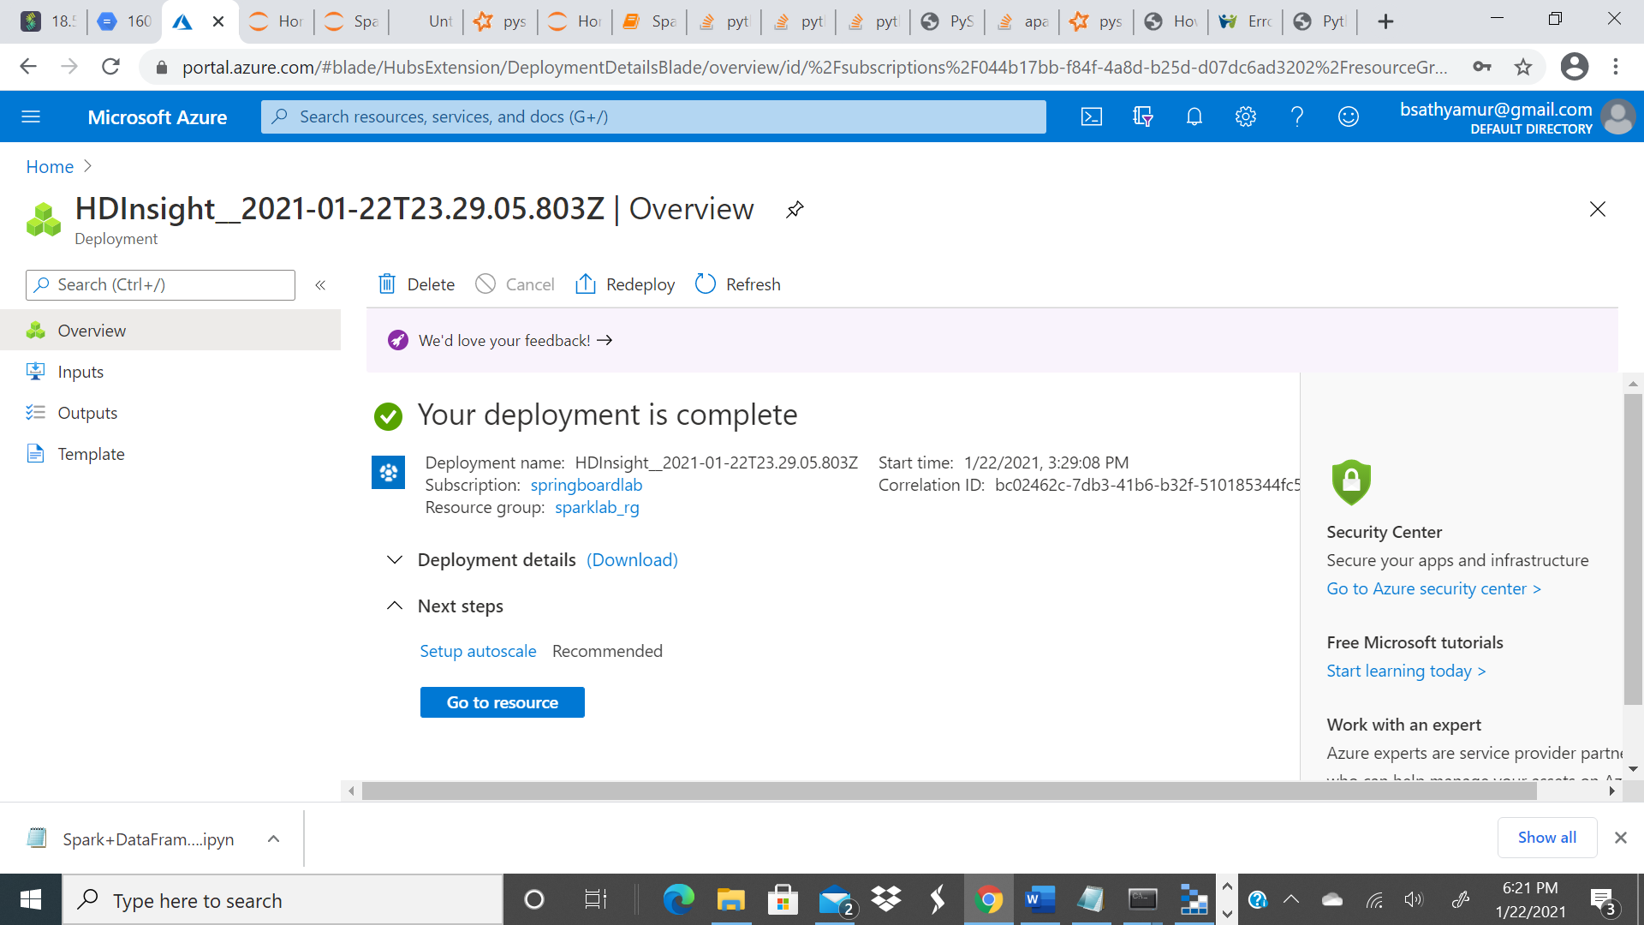

1. Using azure storage explorer uploaded the .pynb notebook and Walmart.csv file

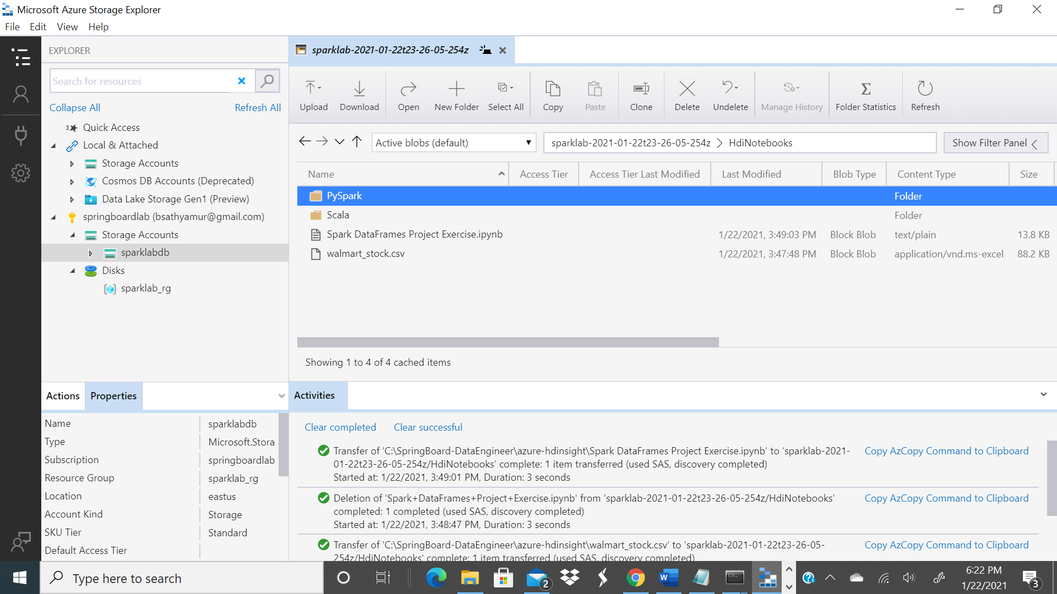

1. Opening the jupyter notebook application in HDInsight

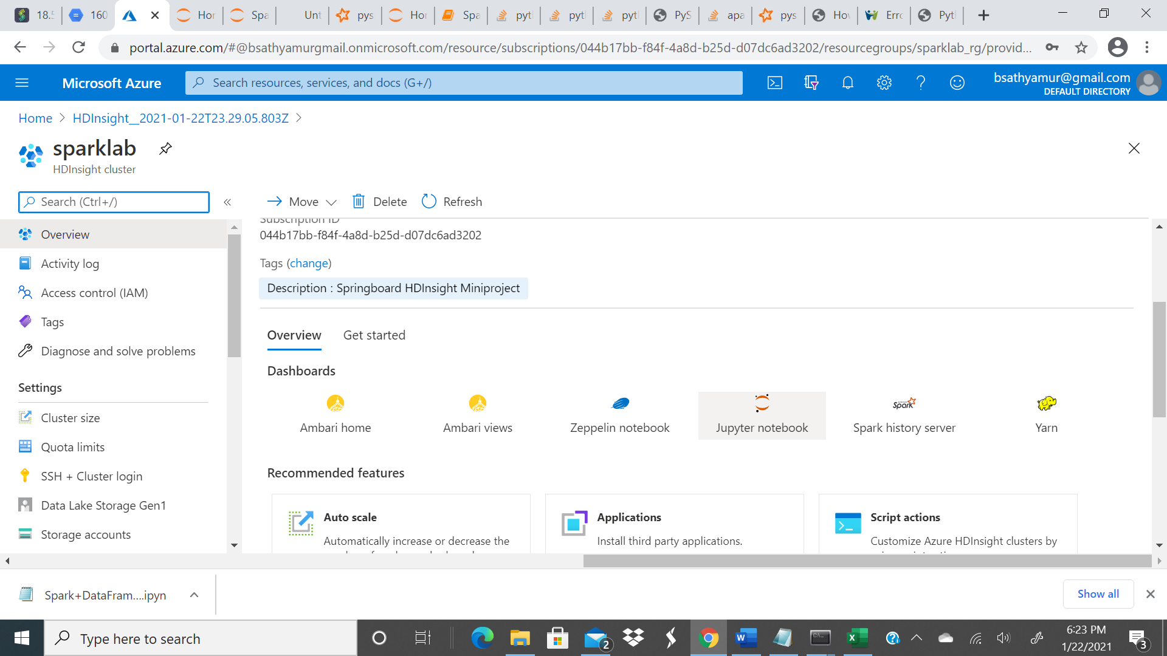

1. Executing the spark commands in the jupyter notebook

